
 THE LIGHTHOUSE
CHRISTMAS GREETINGS
December, 2022

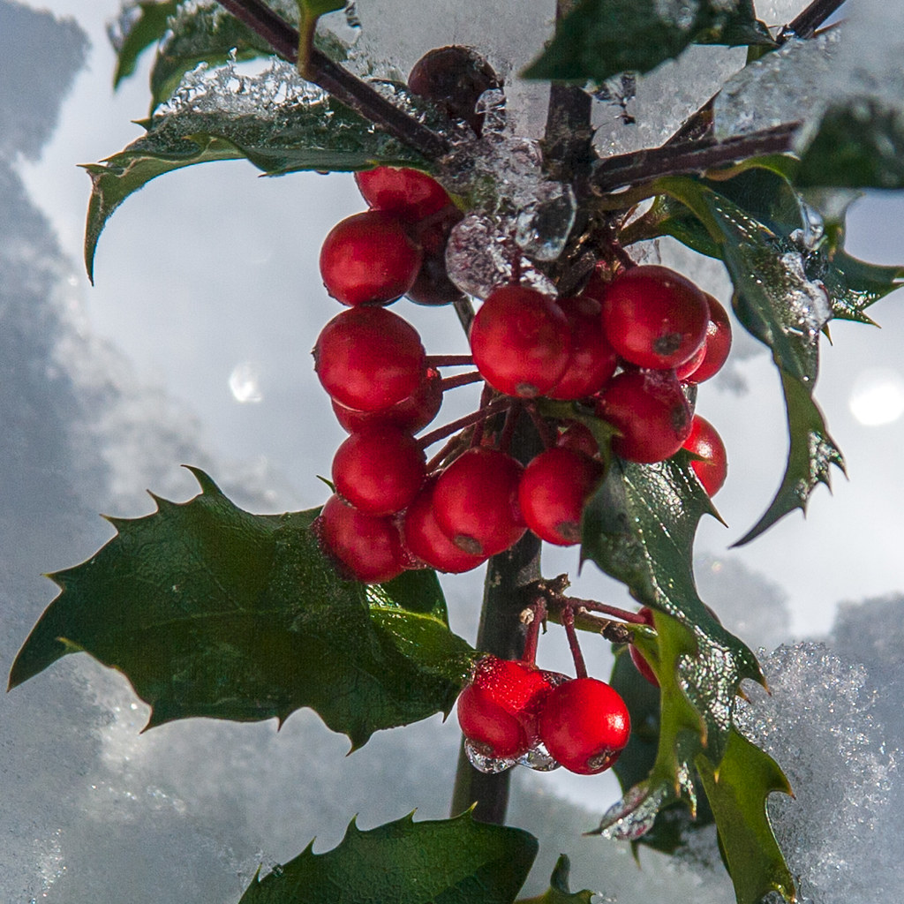

Peace and Grace to you from your Presbyterian Women Synod of the Northeast Moderator, Adebisi Shofu and Vice Moderator, Donna Rahmann.

The Advent season is special in that we await the birth of our Lord and Savior, Jesus Christ, with Hope, Peace, Joy and Love. Hope that the Covid pandemic and its variants will find a way ‘away’ from us. Hope that Peace will be restored in Ukraine and in other areas of our world. Joy that is seen in the expectation of gifts received. And love for all, including our enemies.

We pray for hope, peace, joy, love, and health to each and everyone one of you.

In Christ, we pray,
Adebisi Shofu, Moderator
Donna Rahmann, Vice Moderator

As we look forward to new seasons, SAVE THE DATE, of July 14, 2023 to July 15, 2023 for the Triennial Gathering. The Design Team is in full swing in planning the Gathering. As we anticipate the joy that comes with fellowship at the Gathering, see the below questionnaire. Kindly reflect on the questions contained therein.

Note that All Coordinating Team Members and ALL Presbytery Moderators are expected to attend or send a voting representative (moderators only).

To better plan for the event, it is appreciated if you would complete the following and returning it via email to donnarahmann@comcast.net by mid January, 2023.

Circle preference:

- Would you feel safe enough to attend an in-person meeting. ……………….. Y N

- Will any additional women from your Church/Presbytery attend..................... Y N

- Does your Church/Presbytery have scholarships available for this................. Y N

- Do you need a scholarship from PWSNE…………………………………… Y N

- Would you prefer a less expensive option (church for meeting/motel)……… Y N

- What safety measures would you prefer: ____mask ____vaccination proof ____negative test

- Are learning workshops important to you…………………………………… Y N

- Are roundtable discussions important to you………………………………... Y N
Write suggestions to the following:

How far is too far to travel? ___________________________________________

What month would be best for you ____May ____June ____July ____August

What topic would you like to hear a keynote speaker talk on? ______________________________

Suggestions for a motivating speaker, art/music/drama presentation:

_______________________________________________________________________________

_______________________________________________________________________________

Suggestions to attract younger/other women to attend:

_______________________________________________________________________________

_______________________________________________________________________________

Do you have someone to invite to attend, a mentor or a friend:

_______________________________________________________________________________

