Albany Presbyterian Women’s Newsletter

Commit to the Lord whatever you do, and he will establish your plans. Proverbs 16:3

Winter 2022
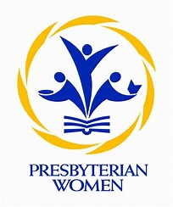

Give thanks to the Lord, for He is good; His love endures forever
Message from Acting Moderator
Charlotte Hasselbarth

2021 Churchwide Gathering theme - Rejoice in Hope.
Be joyful in hope, patient in affliction, faithful in prayer. Share with the Lord’s people who are in need. Practice hospitality. Romans 12:12&13
This is the scripture that was the base for the PW Churchwide Gathering sermon on Thurs, Aug 5, that Diane Givens Moffett, the President and Executive Director of the Presbyterian Mission Agency delivered, which was entitled ”Hope That Will Not Let You Go”. There was something for everyone in her message. Diane included American history, Matthew 25, civil rights, women’s issues among many other perhaps more subtle references. Whatever was heavy on your heart, from personal to global, it was there. See how Diane’s sermon strikes you. The 25-minute sermon is at this link, at 1 hour and 23 minutes into the program.
https://www.presbyterianwomen.org/what_we_do/build-community/churchwide-gathering/
You can also read her sermon in the Sept/Oct edition of Horizons on pages 12-15.

Financial News
Presbyterian Women’s Thank Offering
At the November 3rd Albany Presbytery Meeting, The Presbyterian Women’s Thank Offering was the recipient of the freewill offering. The Presbytery Mission committee chooses a different organization to receive the offering at each meeting. $473.18 has come in to support our Thank Offering Grant program. This year’s promotional video can be seen through the link below. https://www.youtube.com/watch?v=hJAMsTMCwaE
Financial request

The beginning of the year is traditionally a time for reviewing budgets and financial standing so the Presbyterian Women in the Presbytery of Albany (PWA) are asking local groups and individuals who support our projects and mission to consider including us in your donations for 2022. Hopefully we will be able to continue with gatherings, either in person or by Zoom, and will have expenses for speakers’ honorariums or travel. We also support our voting representatives to the PW Synod of the Northeast (PWSNE) and Churchwide business meetings. As you probably know, some of the money coming to the PWA is sent to the PWSNE as a contribution from our PW in our Presbytery. We also set aside funds for sending representatives from the PWSNE on the USA Mission Experience Trips and to Churchwide for Global Exchange Trips. We have recently established a fund to help offset the expense of attending the Bible Study Workshop at Stony Point Retreat Center. Therefore, the money you donate to the PWA fund covers a wide range of expenses that help PWA carry out the missions and programs that reflect Presbyterian Women’s Purpose.

A donation form is included for your convenience. Please be aware that contributions to the Birthday and Thank Offerings, Fellowship of the Least Coin, and Hunger Fund, should be sent directly to the Churchwide office at: Presbyterian Women, Inc. Remittance Processing – Giving, PW Box 643652, Pittsburgh, PA 15264 donations
Contributions to Presbyterian Women in the Presbytery of Albany

Date ______________ Church ________________________________________________

Submitted by _______________________________ e-mail address ___________________

Address _____________________________________________________________________

$______________ Check Number ______________

Make checks payable to Presbyterian Women in the Presbytery of Albany
Send to: Rosalie Hemingway, 3213 Church Street, Valatie, NY 12184
Phone 518-758-7886 email silver3213@gmail.com.

Recap - Presbyterian Women in the Presbytery of Albany Fall Gathering
This was a special Gathering in that it was our first in-person Gathering in two years. Presbyterian Women’s in First Presbyterian Church of Hudson Falls did a gracious job of hosting on Saturday, October 16.
Seventeen women from five different churches attended. The churches represented were First Presbyterian Church of Hudson Falls, First Presbyterian Church of Valatie, Hamilton Union Presbyterian Church, Putnam United Presbyterian Church and Westminster Presbyterian Church. The program was Westminster Presbyterian Church’s African Mission. The speakers were Belinda Quaye, Director of Christian Education at Westminster Presbyterian Church, who spoke on the relationship between youth from Westminster Presbyterian Church and youth in congregations in Tema, Ghana and Lois Wilson, Chair of the African Mission Committee at Westminster Presbyterian Church, who spoke on how the African Mission Program had developed.
The freewill offering totaled $143 and went to the FOCUS Churches of Albany, which is an ecumenical group of six churches that collectively address hunger and homelessness. Belinda Quaye volunteers there. Attendees brought canned goods for the First Presbyterian Church of Hudson Falls Food Pantry. African note cards were sold and the proceeds went to Westminster’s African Mission Program.
Betty Deitz from Hamilton Union Presbyterian Church spoke about the Wizard’s Wardrobe, an afterschool tutoring program in Albany which was a ’17 Thank Offering Grant recipient.
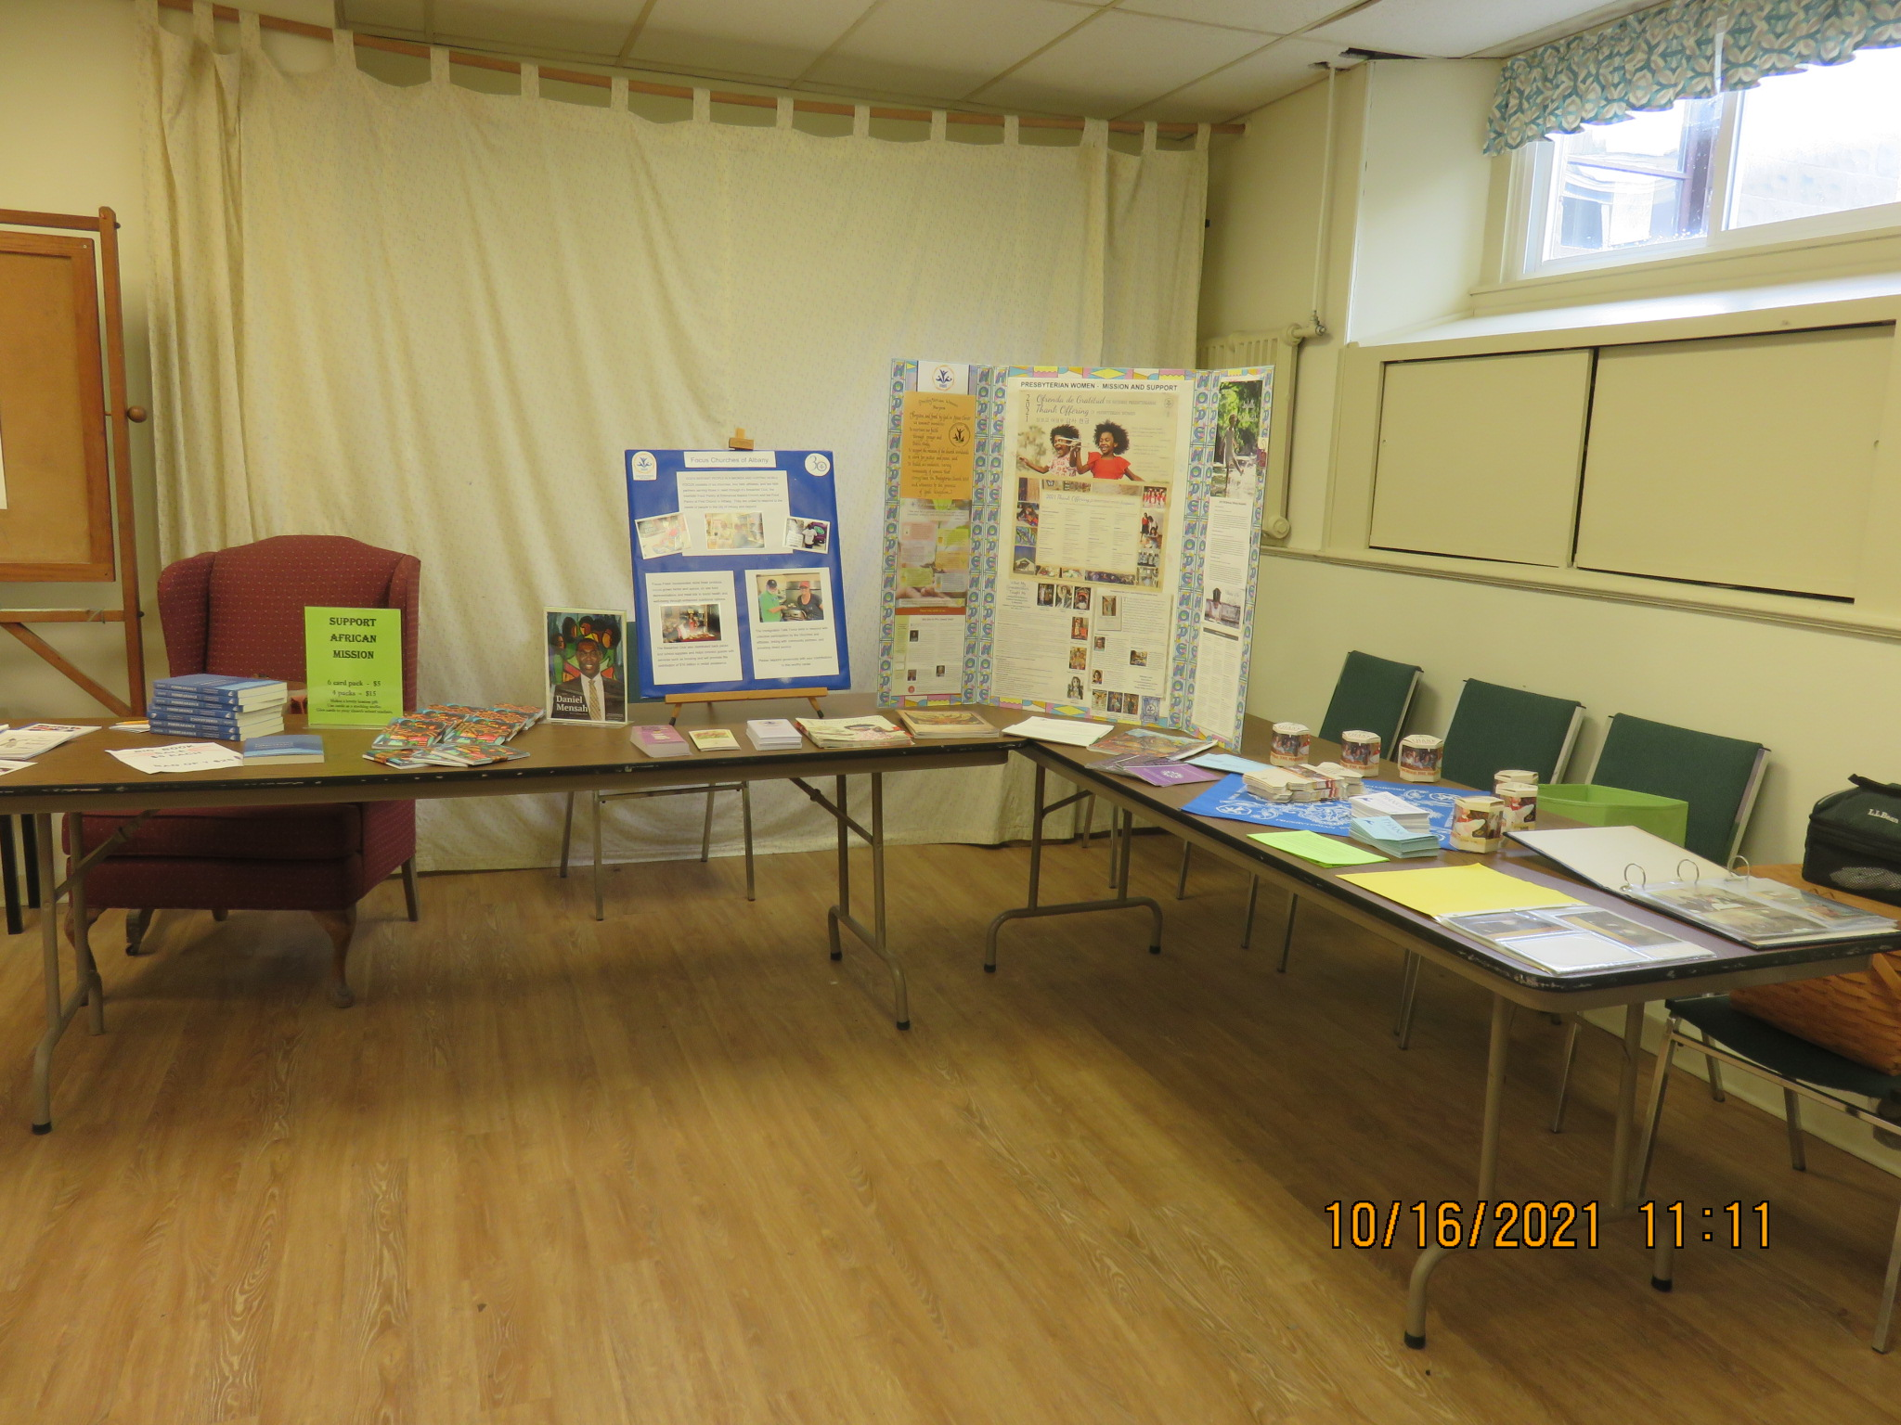
Opening Meditation
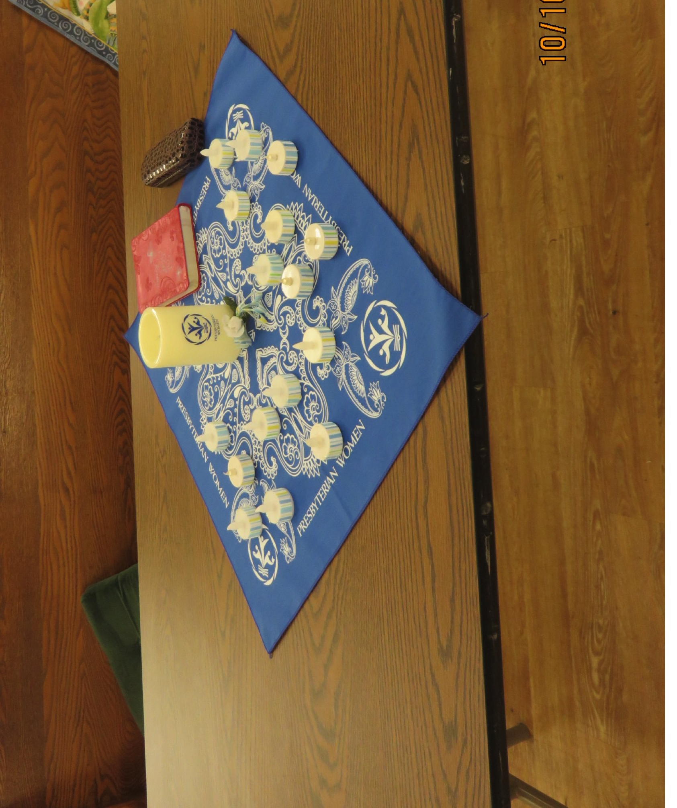
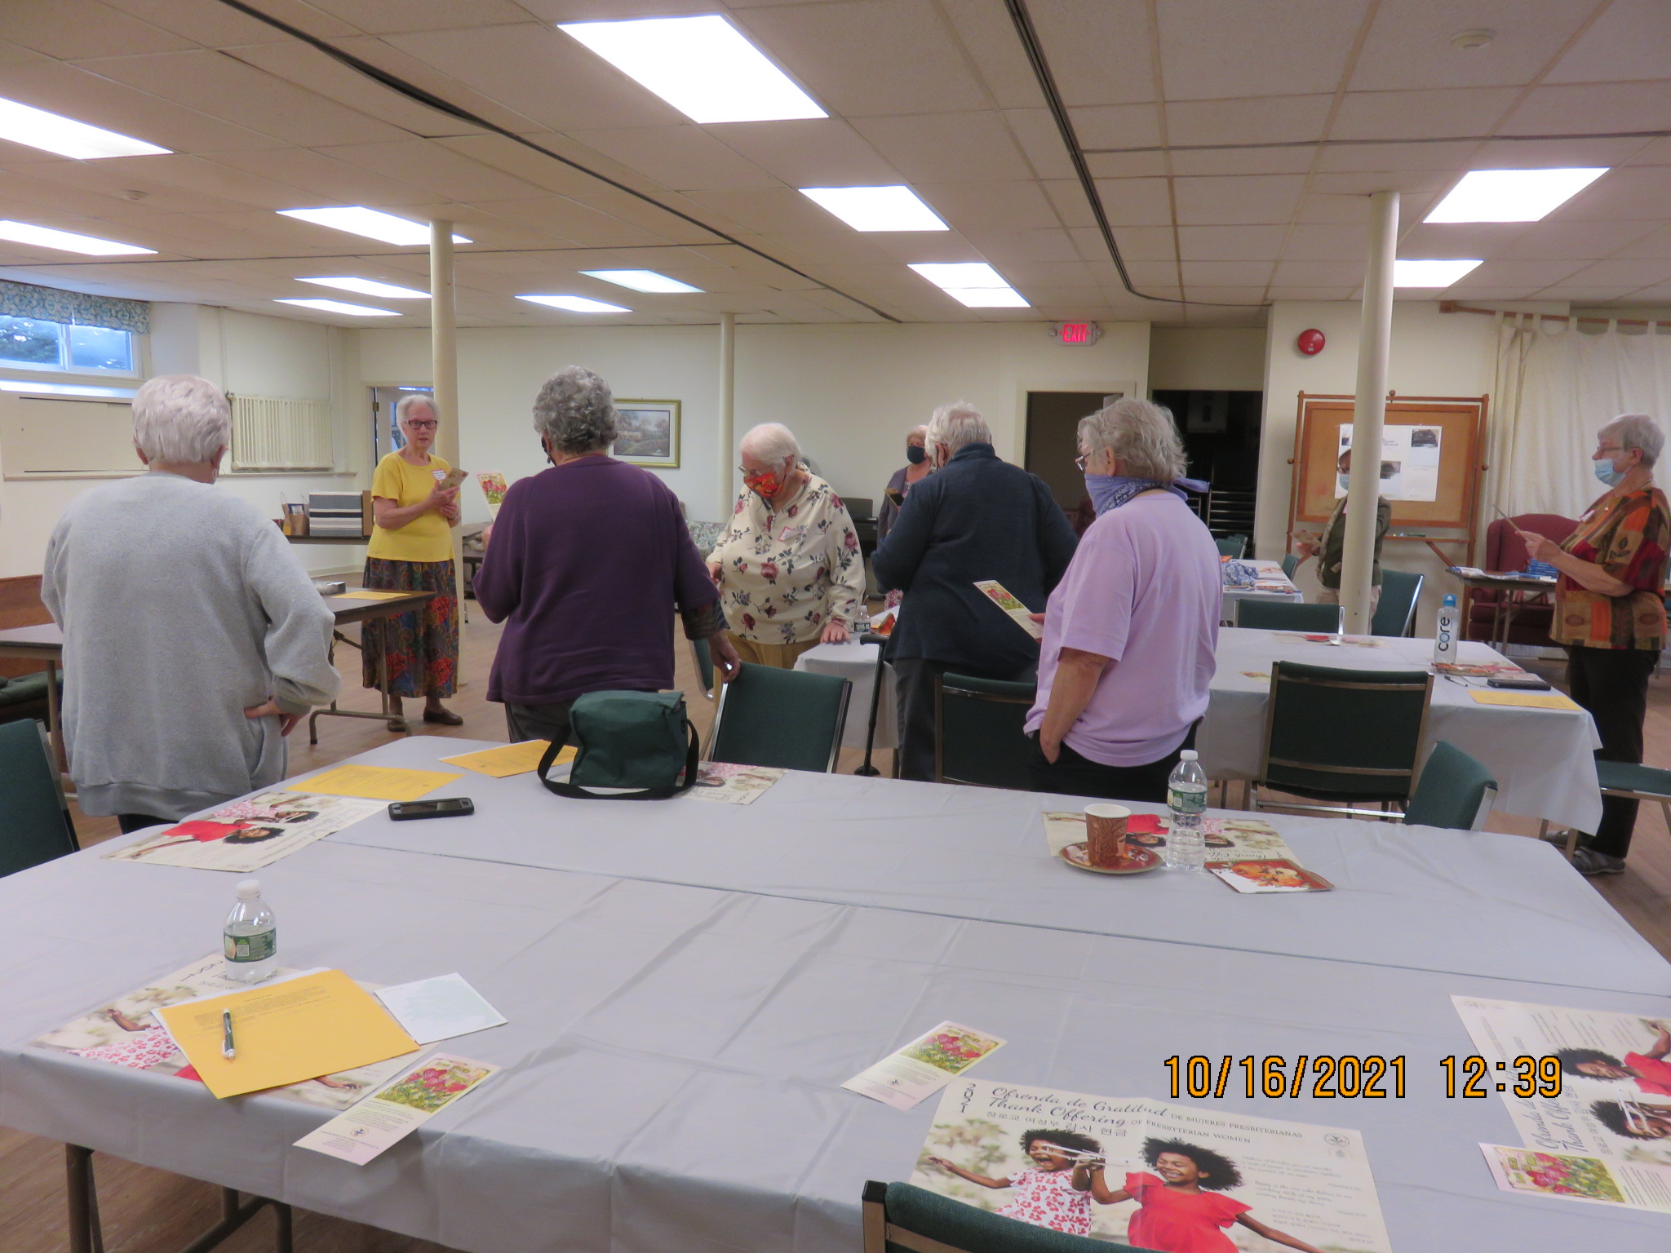
“Reading the Presbyterian Women's Purpose”

A Presence for Food Security, Social Justice and Interfaith Engagement:
The Schenectady Community Ministries

by Rev. Amaury Tañón-Santos, D.Min., CEO of the Schenectady Community Ministries

In 1966, a group of city and regional church leaders gathered to discuss the needs, issues, and opportunities of service to the City of Schenectady. These dialogues, spearheaded by Christian Protestant and Catholic leaders, sought to address racism and discrimination, to focus on urban ministry and mission, and to discern a clear desire for "hands on" (life and work) ministry. The intention from the beginning was to come together, as a cooperative, to resource the religious presence in Schenectady for an intentional, committed, and effective presence for the betterment and wellbeing of those that live and work in the city.

Originally called the Schenectady Ecumenical Urban Ministry, then Schenectady Inner City Ministry (which continues to be our corporate name), and now the Schenectady Community Ministries (SiCM) was organized March 11, 1967 to address urban work in support of senior citizens, housing, children, and youth. As its membership and partnerships grew, SiCM has managed and encouraged social entrepreneurship in service to marginalized and disenfranchised populations in the city and the county, including children and youth, women, senior citizens, housing, POC (persons of color), immigrants, health (physical and mental) wellbeing, and food insecurity.

Our work today is mostly focused in food access for all. We have grown to be an interfaith organization serving with and alongside the communities of Schenectady County by:
- Running the largest food pantry in Schenectady County. In fiscal years 2020 and 2019, respectively, we served close to 600k and 400k meals worth of food, impacting over 10,000 households a year.
- Managing now close to 2-acres of urban farmland in three spaces throughout the City of Schenectady that provides a space for intercultural community engagement around knowing the land, working with it for sustenance, and collaborating with bees, chickens, rabbits, and wildlife in that work.
- Deploying the county-wide summer meals program. This opportunity to provide accessible and nourishing food to children and youth 18-years-old and younger allowed SiCM and its partners to share close to 60k meals (breakfast and lunches) each summer of 2020 and 2021 (and in the middle of the pandemic) in close to 30 sites.
- By being a safe space for our guest, farm members, volunteers, and staff. In 2022 it will be 55 years of SiCM growing into a justice-encouraging, social entrepreneurship-incubating space that has spun off close to two dozen organizations, most of which continue to serve Schenectady and the greater Capital Region of NYS.

SiCM’s work is possible because we are a collaborative of faith communities seeking to impact and be impacted by the struggles for justice and pursuits of wellness of everyone that calls Schenectady home. One of the supporters of this work is the Presbytery of Albany – of which SiCM is a mission partner with. I am profoundly thankful for this opportunity to connect with the Presbyterian Women of Albany Presbytery because there are many connections between the mission priorities of congregational and presbytery-wide Presbyterian Women, and the community engagement we lead. I welcome the opportunity to be in conversation with you around the work SiCM does in and with Schenectady, about ways in which you can participate in and support this work, and/or to organize a visit of our ministries. Please, feel free to email me at ed@sicm.us with any comments or questions you might have.
We also welcome your financial support. If you prefer online, you can do so at sicm.us/donate. If you prefer by mail, you can mail your check to
Schenectady Community Ministries
P.O. Box 1049
Schenectady, NY 12301
I pray this introduction to Schenectady Community Ministries encourages and challenges your missional heart. I look forward to reading or hearing from you soon.

Presbyterian Women in the Synod of the Northeast - Donation to Presbyterian Disaster Assistance

PW in the Synod of the Northeast would like to send a financial contribution to the Presbyterian Disaster Assistance fund specifically for the fund for the December Tornadoes that hit Western Kentucky on Dec.10.
If you're interested in participating in the donation send a check to the PWSNE Treasurer, Nancy Lack. Make it payable to PWSNE and write in the memo PDA-Kentucky. Nancy's address is 15 Lincoln Ave, Florham Park, NJ 07932.

The Lighthouse – Needs to Hear From You
Presbyterian Women in the Synod of the Northeast Newsletter
Susan Silliman Smith, the Lighthouse Editor is interested in hearing from you. All women involved in PW have something good to share. If you alone or your group has done something that illustrates the PW Purpose, please send Susan an article on it.
The next deadline is February 12th. The newsletter will come out a few weeks after that. Put PW Lighthouse Feb 2022 in the subject line. Send articles to august13sss@gmail.com.

PW in Hamilton Union Presbyterian Church – Christmas Mission Project
Gifts for a Living Resources Inc. Group Home, With a Personal Connection,
From the Living Resources Inc. Albany New York website.
https://www.livingresources.org/category/today-at-living-resources

The wonderful folks of Hamilton Union Presbyterian Church (HUPC) have been sponsoring one of our residences for Christmas gifts for many years. They have a special bond with the residents of this house because one of our individuals, Brian, and his family are beloved members of their congregation. Brian grew up in the church and was part of the church's “Special Friends” class from a young age.
Carmen, the medical assistant at the house, get ideas for gifts from her individuals, who typically request things like pajamas and socks. Carmen gives the information to Brian’s father who relays the suggestions to Cindy Schultz, from HUPC. Then, the Hamilton Union Church “Presbyterian Women” (aka PW) jumps into action purchasing and wrapping gifts. They also provide warm hats and gloves from their Mitten Tree and plastic “candy canes” filled with chocolates. In addition, this year, all the individuals received a greeting card with a dollar bill in it. On Christmas morning, our individuals opened their surprises with delight and joy.
Cindy said that HUPC is a “very giving congregation” that truly enjoys providing for our residents in this way. “Those in the house love receiving the gifts and it enriches our lives too. It’s very much a win-win situation.”
We are grateful for this beautiful partnership between the Hamilton Union Presbyterian Church and Living Resources and we thank them from the bottom of our hearts!
* Note from PW in Hamilton Union Presbyterian Church has been involved in this particular Living Resources Inc. group as a mission of our group for over 15 years. We also give the men Easter baskets.
Churchwide Presbyterian Women’s Annual Fund Needs Your Support.
There are many ways to give.
Presbyterian Women’s Annual Fund (the Mission Pledge) makes possible every mission, program and resource of PW, including the Churchwide Gathering. Give now to support Presbyterian Women’s witness in the world.
You can give securely online at www.presbyterianwomen.org/give or mail your gift to Presbyterian Women, PO Box 643652, Pittsburgh, PA 15264-3652.
Contact Rhonda Martin, rhonda.martin@pcusa.org, to consider other ways to support PW (estate plans, endowments, gifts of stoc
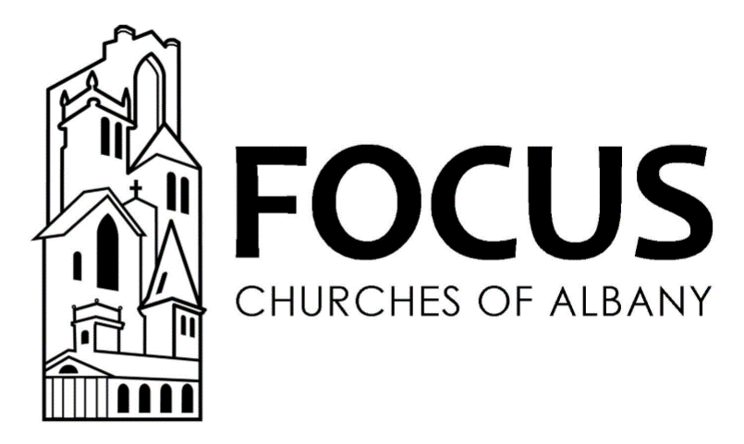
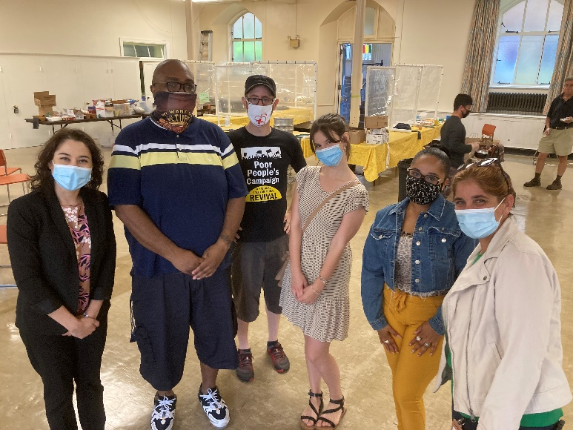
FOCUS Breakfast Coordinator James Blount (second from left) with outreach workers who serve our Breakfast guests.

FOCUS Churches of Albany offers a nutritious hot breakfast three mornings a week in the Fellowship Hall of Westminster Presbyterian Church. In addition to feeding people, we also provide assistance with housing, healthcare, job training and advocacy. Might you like to join us in this special ministry, as we serve our neighbors who are food insecure? We are seeking volunteers who might be available between 7am and 8:30am Tuesdays, Wednesdays, and Thursdays. Two perks of volunteering are spending time with terrific people and enjoying a hot breakfast. Please join us! For more information, please contact Belinda Quaye, FOCUS Volunteer Coordinator: belindaq@focuschurches.net or (518) 443-0460 ext. 2.

Help Needed - Someone to Organize Digital and Hard Copy Photos
We have many nice digital and hard copy photos from local, regional and churchwide PW events that need to be labeled as to who is in them and at what event it was. We need a few people to organize and create a medium for which they can be enjoyed. PW in the Albany Presbytery has a rich history that we wish to preserve and share. If you can help, contact Charlotte Hasselbarth at chasselbarth@hotmal.com

Finance Committee Member needed
The Capital Area Council of Churches is looking for Finance Committee members if you are interested please contact Elder Andrea Ralph at aralph20@hotmail.com
Description for Finance Committee Member:
The Capital Area Council of Churches is seeking members to serve on the Finance Committee. The Finance Committee, in conjunction with the Treasurer, is responsible for providing financial oversight for the Council. This includes developing an annual budget, setting long term financial goals, developing internal controls, recommending policies to the board, reviewing the Treasurer’s books, and administering the endowment funds. Candidates for this position should be comfortable with numbers and have the courage to keep the organization accountable. Bookkeeping, accounting, or other fiscal experience a plus.

Cast your cares on the Lord and he will sustain you; he will never let the righteous be shaken.
Psalm 108:1

Elder Andrea Ralph
editor

