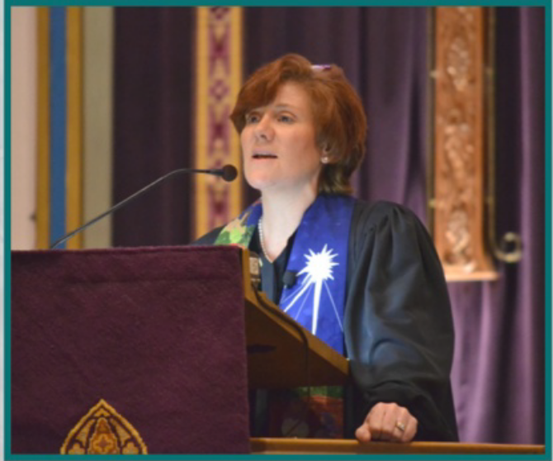
Spring Women’s Retreat
April 17-19, 2020
Bread for the Journey
Explore stories of bread in the Bible
as we find what feeds our soul!
Led by Rev. Diane Jamison Fitch
Rev. Diane Jamison Fitch is a hospice chaplain in the
Philadelphia area. a wife and a mother, who has been doing
ministry for 27 years. She delights in developing
community, teaching, fostering creativity, and the power of
the stories. Diane is excited to guide those attending a time
of rejuvenation and in nourishing their faith.

Join women of all ages for a weekend of faith sharing,
rejuvenation and recreation
• Large group sessions
• Hiking
• Boating
• Zipline
• Engaging Worship
• Made from scratch meals
• Small group discussions
• Massage (available for an additional fee)
• Campfire
• Starwatch ( weather dependent)
• Fellowship
• Laughter and much more!

All of this will create a memorable weekend not to be missed!
Two Nights - Semi-private Room - Tier 1 $180, Tier 2 $200, Private Room Tier 1 $220, Tier 2 $240
Includes Two nights lodging with Linens and Friday dinner through Sunday Lunch (6 meals)
One Night - Semi-private Room - Tier 1 $125, Tier 2 $145, Private Room Tier 1 $165, Tier 2 $185
Includes One night lodging with Linens and Fri. dinner to Sat. Dinner or Sat. Lunch to Sun. Lunch (4 meals)
Saturday Only - Tier 1 $45, Tier 2 $65, includes Saturday Lunch & Dinner (2 meals)

Register online - www.campjburg.org
Click on the Green Register Online Button, Login to your account or create an account
If you have any questions, email: office@campjburg.org or call (908) 852-2349

Johnsonburg Camp and Retreat Center • 822 County Road 519 • Johnsonburg NJ, 07825

